

**TECHNICAL ANALYSIS SCREENER_2 HEIKIN ASHI**

Software Requirement Specification (SRS) Document

Sprint Implementation

Project Timeline: 07.11.2022 to 12.11.2022

**INDEX**

1. Introduction……………………………………………………… 3

1.1 Background……………………………………………….. 3  
 1.2 Purpose…………………………………………………..... 3  
 1.3 How Stock Screeners Work……………………………….. 3  
 1.4 Key Project Objectives…………………………………...... 4  
 1.5 Functional Overview……………………………………..... 4  
 1.5.1 Header Files………………………………………….. 4

2. Heikin-Ashi………………………………………………………… 5

2.1 What is a Heikin-Ashi?…………………………………….. 5

### Heikin-Ashi Formula………………………………………6

3.Overall Description………………………………………………… 6

3.1Assumptions and Dependency………………………………… 6

4. System Feature and Requirement…………………………………… 7

4.1 functionality………………………………………………. 7

4.2 System Requirements………………………………………. 7

5.Detailed system design……………………………………………… 8

5.1 Data Overview……………………………………………. 9

5.2 System Architecture………………………………………. 10

**1. INTRODUCTION**

A stock screener is a set of tools that allow investors to quickly sort through the myriad of available stocks and increasing Exchange-traded funds according to the investor’s own criteria. Stock screeners are most typically available on brokerage trading platforms (usually free), but there are also some independent subscription-based stock screeners available. Stock screeners allow investors to employ their own methodology about what makes a stock or ETF valuable (longer-term traders) or spot a potential trading opportunity (shorter-term traders).

**1.1 BACKGROUND**

Technical analysis is an approach to predicting future price movements based on identifying patterns in prices, volume and other market statistics. Technical analysis usually proceeds by recording market activity in graphical form and then deducing the probable future trend from the pictured history. The premise is that prices exhibit various geometric regularities, which, once identified, inform the trader what is likely to happen next. This in turn allows the trader to run a profitable trading strategy. Technical analysis is prevalent in financial markets and is readily accessible in practitioner texts such as pring (2002), in the form of tools provided by online brokers such as Barclays Stockbrokers (www.stockbrokers.barclays.co.uk) as well as in the form of commentary in the financial and investment press.

**1.2 PURPOSE**

Technical stock screeners allow you to filter stocks according to many of the same price-dependent technical indicators that you would use on a stock chart. So, technical screeners can be extremely valuable for traders who normally trade momentum, reversal, or other short- and medium-term strategies.

**1.3 HOW STOCK SCREENERS WORK**

Stock screeners allow investors to weed through the extensive field of potential financial investments using their own criteria. Users begin the process by selecting certain investing parameters, based on their personal requirements.

For example, a fundamental investor may be most interested in market capitalization, analyst recommendations, earning per share (EPS), operating cash flow, multi-year return on investment (ROI), dividend yield, and the like. A technical trader would be more interested in moving average levels/crossovers, relative strength index (RSI) levels to indicate momentum, average directional index (ADX) readings to indicate strength, and chart patterns, among others.

**1.4 KEY PROJECT OBJECTIVES**

* To supply capital - To achieve this task, ownership in a private corporation is sold to the public in the form of shares of stock. Funds received from the sale of stock contribute to the firm’s capital formation.
* Toinspiresavings - This inspires people to save their income by making a profit. Continuous purchase and sale of securities on a stock exchange lead to the evaluation of their prices.
* Todevelop economy - It helps economic development by supplying the capital to the industries.
* To protect fraudulently**-**It is also to ensure that no fraudulence occurs in a transaction.
* To do long-term financing - Commercial banks generally disburse the short-term loan. So, supplying long-term finance is an objective of the stock exchange.

**1.5 FUNCTIONAL OVERVIEW**

**1.5.1 HEADER FILES**

* stdio.h
* stdlib.h
* string.h

**2. HEIKIN-ASHI**

## 2.1 What Is a Heikin-Ashi?

The Heikin-Ashi technique is used by technical traders to identify a given trend more easily. Hollow white (or green) candles with no lower Shadows are used to signal a strong Uptrend, while filled black (or red) candles with no upper shadow are used to identify a strong downtrend.

The Heikin-Ashi trading technique was developed by Munehisa Homma in the 1700s. The technique shares some characteristics with the traditional candlestick charts used in trading but differs in how the values for candlesticks are computed. In Japan, the word Heikin means “average” or “balance,” and the word Ashi means “bar” or “foot.” Hence, Heikin-Ashi means “average bar,” resonating with the trading technique, which uses the average price of the security.

### **2.2 Heikin-Ashi Formula**

When calculating the Heikin-Ashi formula, we use the open-close data from the previous period and the open-high-low-close (OHLC) data from the current period. Modified OHLC values are displayed as candlesticks. The computations are as given below:

Heikin-Ashi Close = (Open() + High() + Low() + Close)/4

Heikin-Ashi Open = (HA Open(-1) + HA Close(-1))/4

Heikin-Ashi High = Max (High0, HA Open0, HA Close0)

Heikin-Ashi Low = Min(Low0, HA Open0, HA Close0)

Where:

* **HA** – Heikin-Ashi
* **-1** – Prior period figures
* **0** – Current period figure

Heikin-Ashi data can be of different time frames, i.e. intraday, weekly, or monthly, etc. The HA Open is always set to the midpoint of the body of the previous bar, and the HA Close is calculated as the average price of the current bar. The HA High is the highest value among the current high, HA Open, and HA Close. HA Low is the lowest value among the current low, HA Open and HA close.

**3.Overall Description: -**

It is a technical stock screener allow you to filter stocks according to many of the same price-dependent technical indicators that you would use on a stock chart. This consists of information of the stock. It will give the information about which uptrend stock and down trend and next in which stocks to invest. Continuously shows the trend of the stocks so far after each candlestick. on demand will on entering the stock id and stock details should be displayed which includes the data available in the stock The main purpose of this project is to automate the process of keeping track of the stocks and give buy and sell recommendation.

**3.1Assumptions and Dependency: -**

* System should have Ubuntu Linux installed.
* · System should have either 4GB or more RAM.
* The service is used preferably on a desktop or laptop.

**4.System Features and Requirements: -**

**4.1 Functionality: -**

**4.1.1 TA_01 🡪void append linkedlist:** this function is used to add the extra stock Record by adding new stock details

**4.1.2 TA_02 🡪Displaystocks():** This function is used to display the stock details that are provided by the user.

**4.1.3 TA_03 🡪void print linkedlist():** this function is used to add the extra stock Record by adding new stock details

**4.1.4 TA_04 🡪load from file():** This function will load the files of stocks in the application.When user select anyone stock from list then that file get load from this function.

**4.1.5TA_05🡪free linkedlist():** This function will deallocated all the dynamic memory which is allocated in program.

**4.1.5TA_05🡪hclose():**This function is used to chose and provide recommendation for buy and sell

**4.2 System Requirements:**

* + - * Valgrind
      * Make file
      * Splint

**5. DETAILED SYSTEM DESIGN**

**5.1 DATA FLOW DIAGRAM**

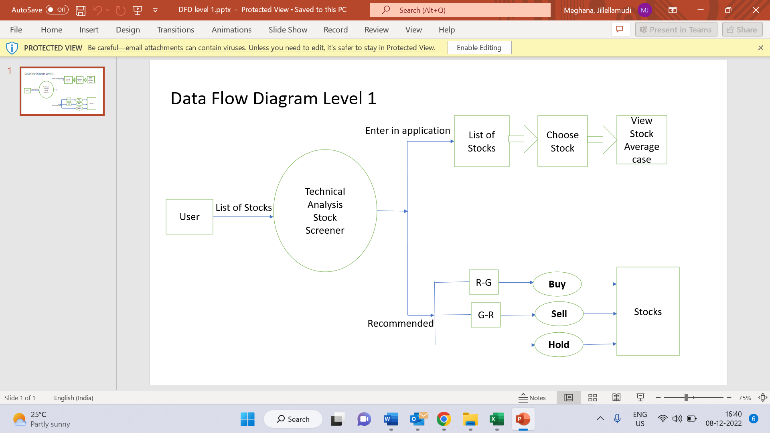

**5.2 DATA OVERVIEW**

**5.3 SYSTEM ARCHITECTURE**

user

Recommend to buy or sell based on Heikin Ashi candle stick colour changing pattern

Append and update stock details up to 20 stocks and display

Create

Stock details

Such as stock id, stock name,

Stock low,

Stock high, stock volume